Supporting Information for
Peruranolides A-D, four new withanolides with potential antibacterial and cytotoxic activity from Physalis peruviana L.
Qian-Ran Li^{1,†}, Hui-Jun Liang^{1,†}, Bai-Lin Li¹, Jie Yuan¹, Zhuo-Yi Ao¹, Yu-wen Fan¹, Wei-Jie Zhang¹, Xin-Lian¹, Jia-Yan Chen¹, Jian-zhong Wang^{2,*} and Jie-Wei Wu^{1,*}
¹School of Chinese Herbal Medicine, Guangzhou University of Chinese Medicine, Guangzhou, 510006, Guangdong, China
²The second affiliated hospital of Wenzhou Medical University, No. 109 Xueyuan Xi Road, Wenzhou, 325027, Zhejiang, China
*Correspondence: wzwjz@yeah.net (Jian-zhong Wang) ; wujiewei@gzucm.edu.cn. (Jie-Wei Wu)
† These authors contributed equally.

Abstract
Background: Many drugs for anti-tumour have been developed, nevertheless, seeking new anticancer drug is the focus of ongoing investigation. Withanolides have been reported to possess potent antiproliferative activity. Literature findings revealed that a diversity of withanolides were obtained from Physalis peruviana, however, the antitumor activity of these bioactive compounds is still unclear; Methods: The EtOAc fraction of P. peruviana were decolorized on MCI gel column, repeatedly subjected to column chromatography (CC) over sephadex LH-20, preparative HPLC and silica gel to afford compounds. Their chemical structures of the new isolates were elucidated through analyzing spectroscopic and HRESIMS data. All these obtained metabolites were appraised for their potential antiproliferative activity against the human breast cancer cell line MCF-7 by MTT assay, and in vitro antibacterial activity of the isolated compounds (1–7) were evaluated against E. coli, B. cereus and S. aureus. Results: Four new withanolides, including one withaphysalin-type withanolide (peruranolide A, 1), two 13,14-seco-withaphysalins (peruranolides B–C, 2–3), as well as one normal withanolide (peruranolide D, 4), were purified and separated from P. peruviana L.. Compound 5 was discovered to exhibit potent cytotoxic effect with an IC₅₀ value of 3.51 μM. In vitro antibacterial activities, compounds 1–7 had no obvious inhibitory activity against E. coli, but had moderate inhibitory activities against B. cereus and S. aureus. Conclusions: Our findings might offer valuable clues for the utilization of withanolides as lead compounds for antineoplastic or antibacterial drug development.

Keywords
Withanolides; Physalis; Structure elucidation; Antiproliferative activity; Antibacterial activity

General experimental procedures
Optical rotation was measured with a Perkin-Elmer 341 polarimeter (Perkin-Elmer, Boston, MA, USA). IR spectra were obtained on a Nicolet Magna FT-IR 750 spectrophotometer using KBr disks. 1D and 2D NMR spectra were performed on a Bruker Advance-400 spectrometer (Bruker BioSpin AG, Fallanden, Switzerland) with TMS as internal standard. HR-ESI-MS data were obtained on Waters 2695-3100 LC-MS and Waters Xevo TOF mass spectrometers. Preparative HPLC was carried on a Agilent 1100 series with a Waters Sunfire RP-C₁₈ column (30 mm × 150 mm, 5 μm) and a UV detector at 210 nm, accompanied by a flow rate of 20.0 mL/min in a H₂O and CH₃CN gradient solvent system. Column chromatography (CC) was performed on Silica gel (200–300 and 300–400 mesh, Qingdao Marine Chemical Industrials, Qingdao, People’s Republic of China), Sephadex LH-20 (Pharmacia Fine Chemicals, Uppsala, Sweden) and MCI gel CHP20P (75–150 μm, Mitsubishi Chemical Industries, Tokyo, Japan), respectively. Thin-layer chromatography (TLC) was performed on precoated silica gel GF₂₅₄ plates (Yantai Chemical Industrials, Yantai, People’s Republic of China), about the spots were visualized under UV light followed by dipping in Chromogenic agent (5% H₂SO₄ in alcohol) and heating for color development. All solvents were analytical grade (Shanghai Chemical Plant, Shanghai, China).
Supplementary Fig. 1. ¹H NMR spectrum of peruranolide A (1) in MeOD
Supplementary Fig. 2. ¹³C NMR spectrum of peruranolide A (1) in MeOD
Supplementary Fig. 3. ¹H-¹H COSY spectrum of peruranolide A (1) in MeOD
Supplementary Fig. 4. HSQC spectrum of peruranolide A (1) in MeOD
Supplementary Fig. 5. HMBC spectrum of peruranolide A (1) in MeOD
Supplementary Fig. 6. ROESY spectrum of peruranolide A (1) in MeOD
Supplementary Fig. 7. IR spectrum of peruranolide A (1)
Supplementary Fig. 8. HRESI (+) MS spectrum of peruranolide A (1)

Supplementary Fig. 9. ¹H NMR spectrum of peruranolide B (2) in MeOD
Supplementary Fig. 10. ¹³C NMR spectrum of peruranolide B (2) in MeOD
Supplementary Fig. 11. ¹H-¹H COSY spectrum of peruranolide B (2) in MeOD
Supplementary Fig. 12. HSQC spectrum of peruranolide B (2) in MeOD
Supplementary Fig. 13. HMBC spectrum of peruranolide B (2) in MeOD
Supplementary Fig. 14. ROESY spectrum of peruranolide B (2) in MeOD
Supplementary Fig. 15. IR spectrum of peruranolide B (2)
Supplementary Fig. 16. HRESI (-) MS spectrum of peruranolide B (2)
Supplementary Fig. 17. ¹H NMR spectrum of peruranolide C (3) in MeOD
Supplementary Fig. 18. ¹¹³C NMR spectrum of peruranolide C (3) in MeOD
Supplementary Fig. 19. ¹H-¹H COSY spectrum of peruranolide C (3) in MeOD
Supplementary Fig. 20. HSQC spectrum of peruranolide C (3) in MeOD
Supplementary Fig. 21. HMBC spectrum of peruranolide C (3) in MeOD
Supplementary Fig. 22. ROESY spectrum of peruranolide C (3) in MeOD
Supplementary Fig. 23. IR spectrum of peruranolide C (3)
Supplementary Fig. 24. HRESI (+) MS spectrum of peruranolide C (3)

Supplementary Fig. 25. ¹H NMR spectrum of peruranolide D (4) in MeOD
Supplementary Fig. 26. ¹¹³C NMR spectrum of peruranolide D (4) in MeOD
Supplementary Fig. 27. ¹H-¹H COSY spectrum of peruranolide D (4) in MeOD
Supplementary Fig. 28. HSQC spectrum of peruranolide D (4) in MeOD
Supplementary Fig. 29. HMBC spectrum of peruranolide D (4) in MeOD
Supplementary Fig. 30. NOESY spectrum of peruranolide D (4) in MeOD
Supplementary Fig. 31. IR spectrum of peruranolide D (4)
Supplementary Fig. 32. HRESI (+) MS spectrum of peruranolide D (4)
Supplementary Fig. 33. Key NOESY correlation for peruranolide D (4)
Supplementary Table 2-1. ¹³C NMR data of Compounds 4 and Physaminimin F (101 MHz)

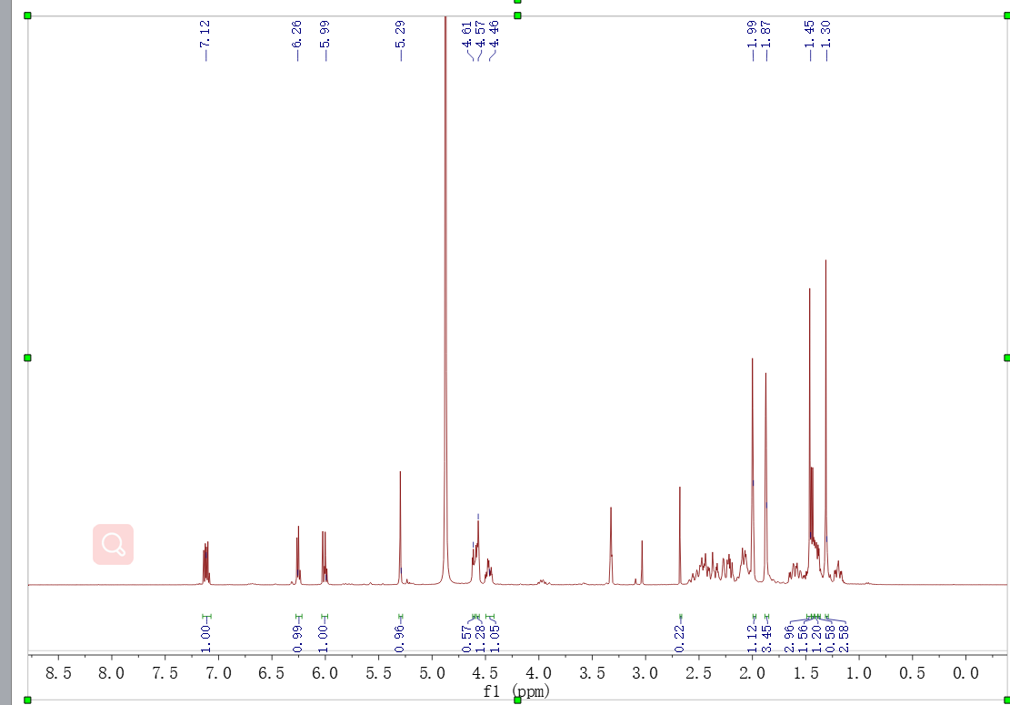
Supplementary Fig. 1. ¹H NMR spectrum of peruranolide A (1) in MeOD
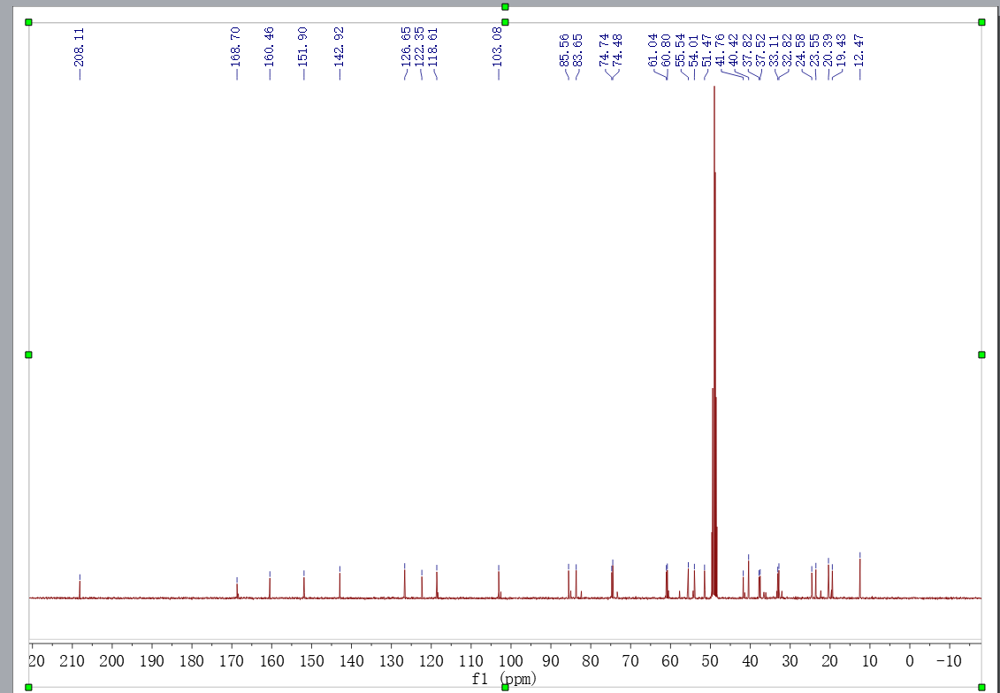
Supplementary Fig. 2. ¹³C NMR spectrum of peruranolide A (1) in MeOD
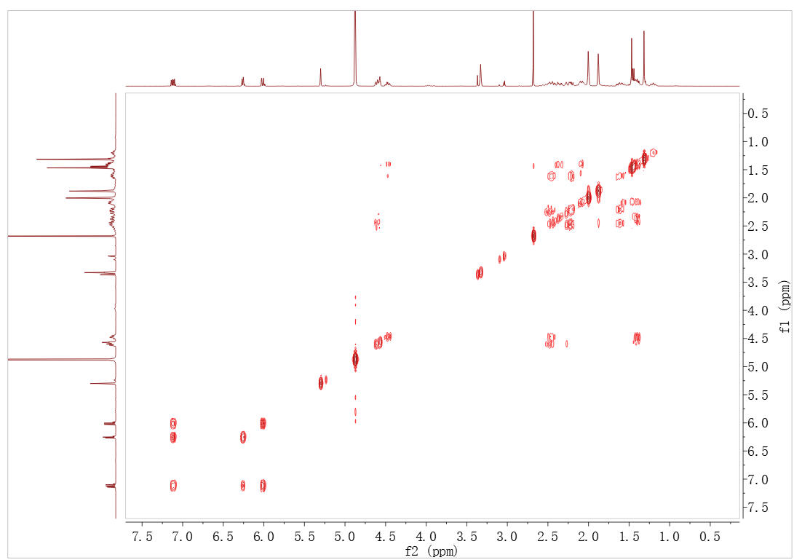
Supplementary Fig. 3. ¹H-¹H COSY spectrum of peruranolide A (1) in MeOD
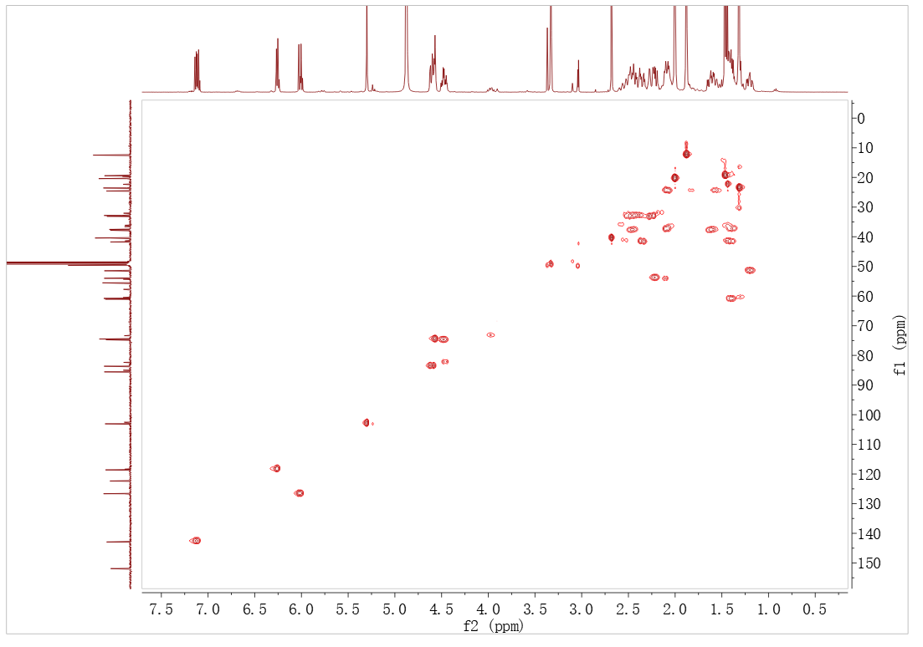
Supplementary Fig. 4. HSQC spectrum of peruranolide A (1) in MeOD
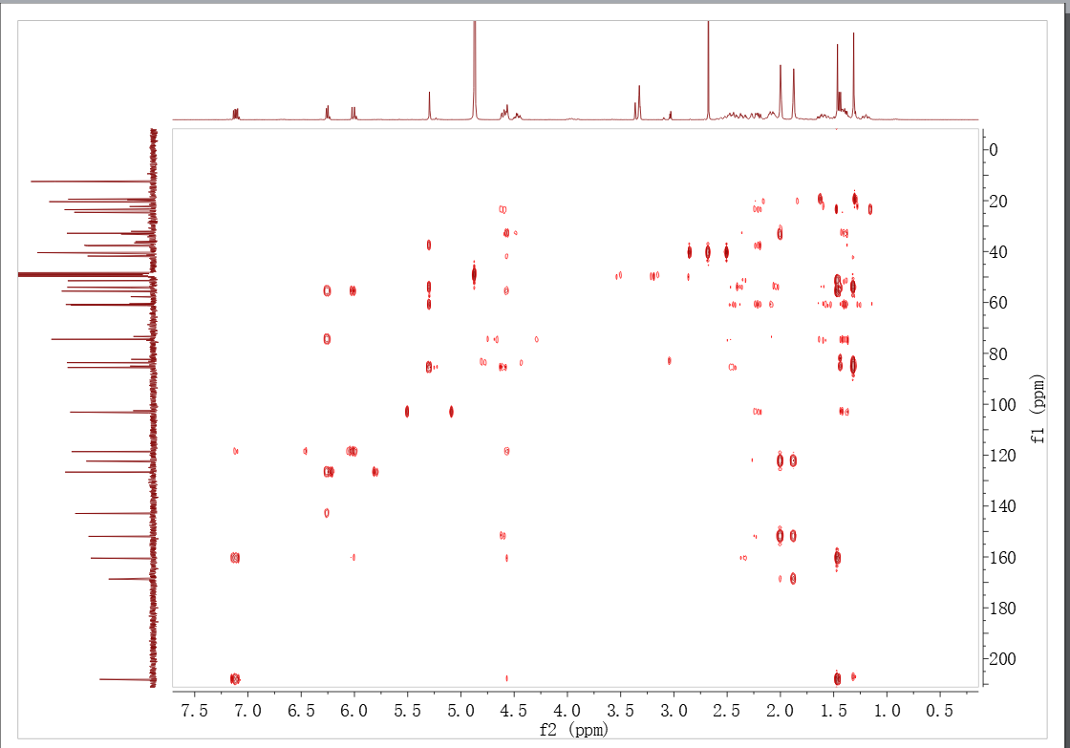
Supplementary Fig. 5. HMBC spectrum of peruranolide A (1) in MeOD
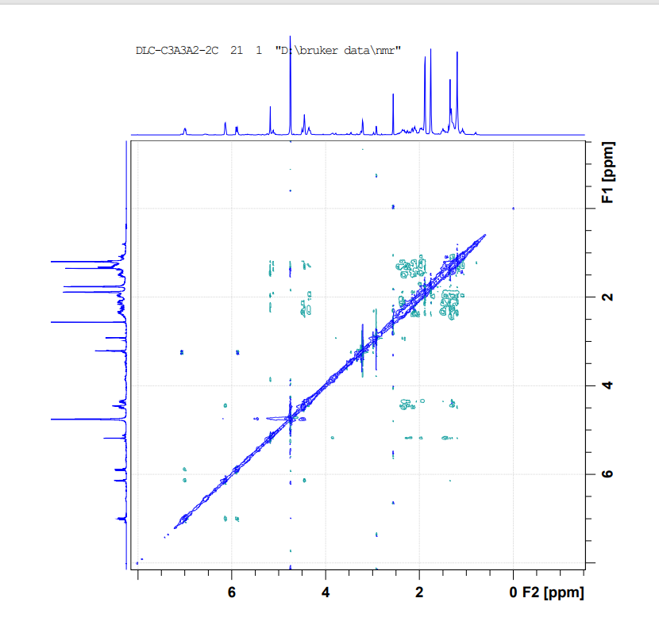
Supplementary Fig. 6. ROESY spectrum of peruranolide A (1) in MeOD
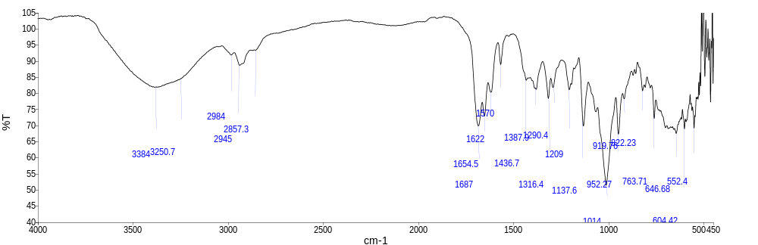

Supplementary Fig. 7. IR spectrum of peruranolide A (1)

Event#: 1 MS(E+) Ret. Time : 8.047 Scan# : 2415
Rank | Score | Formula (M) | Ion | Meas. m/z | Pred. m/z | Diff (mDa) | Diff (ppm) | Iso Score | DBE
1 | 86.69 | C₂₈ H₃₆ O₇ | [M+NH₄]⁺ | 502.2797 | 502.2799 | -0.2 | -0.40 | 86.69 | 11.0

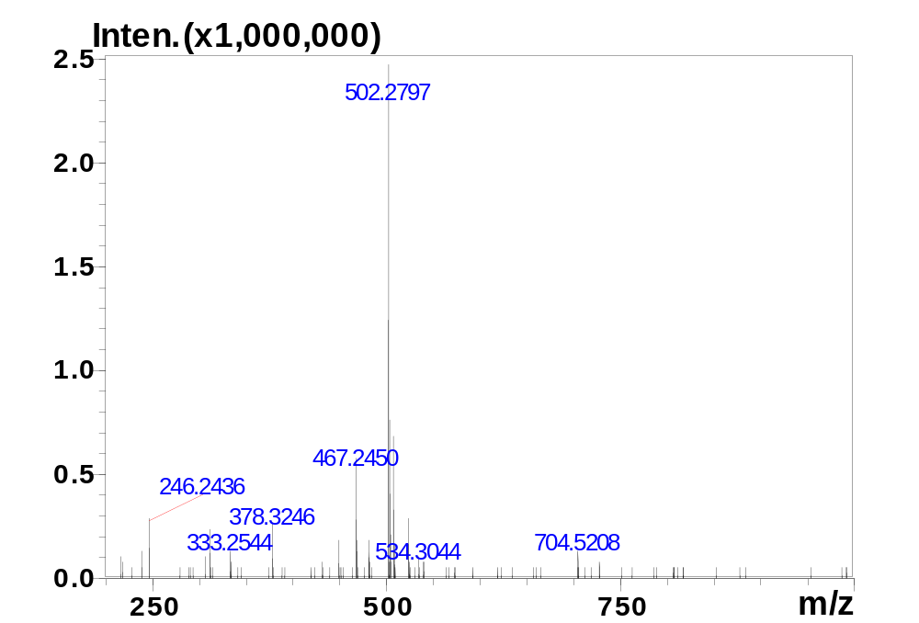
Supplementary Fig. 8. HRESI (+) MS spectrum of peruranolide A (1)

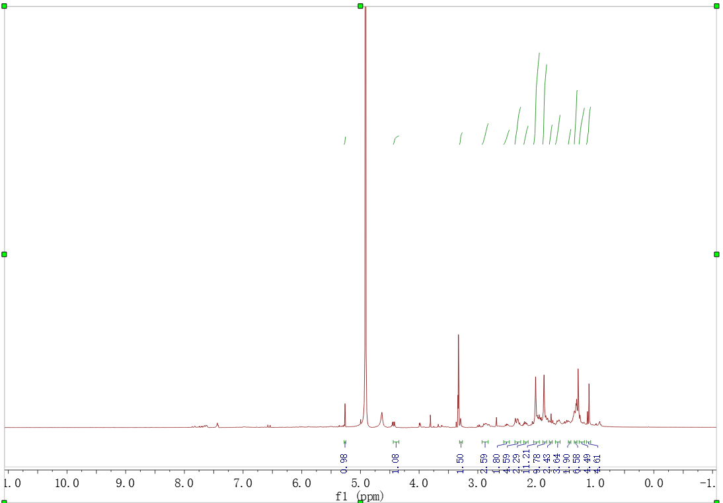
Supplementary Fig. 9. ¹H NMR spectrum of peruranolide B (2) in MeOD
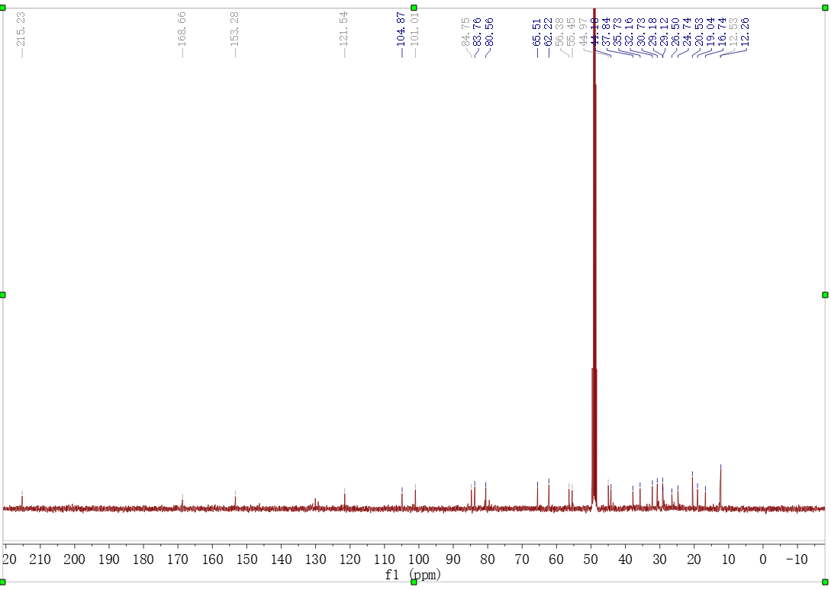
Supplementary Fig. 10. ¹³C NMR spectrum of peruranolide B (2) in MeOD
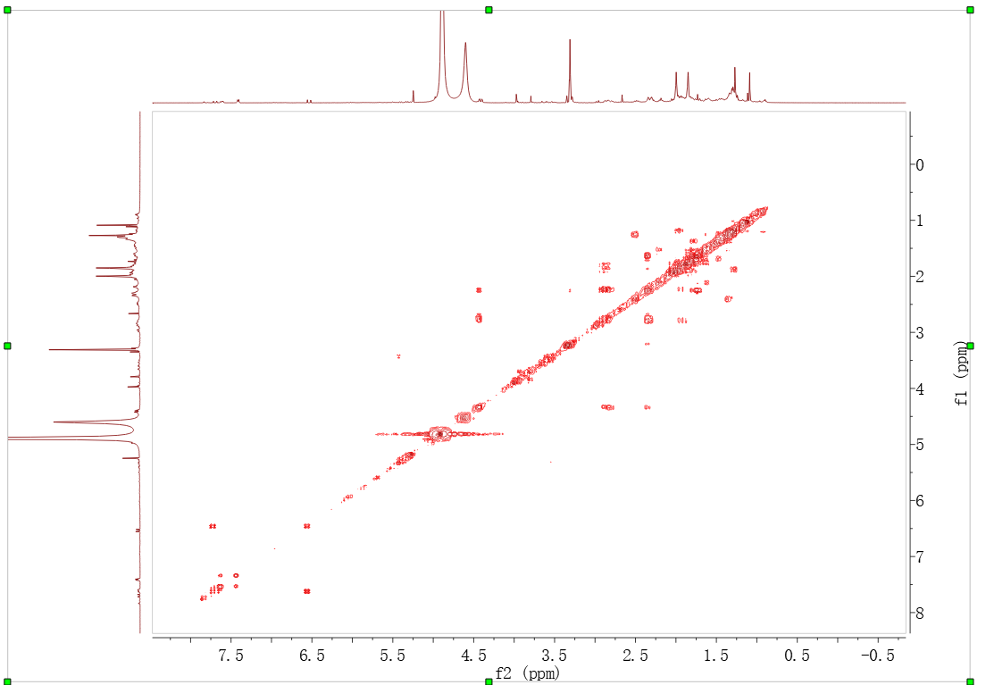
Supplementary Fig. 11. ¹H-¹H COSY spectrum of peruranolide B (2) in MeOD
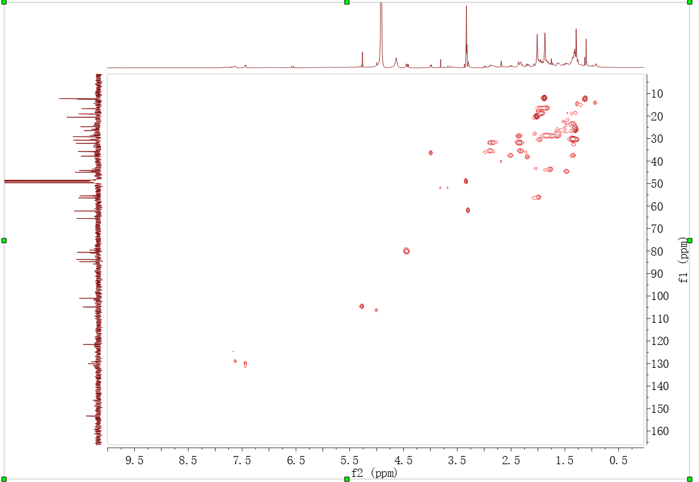
Supplementary Fig. 12. HSQC spectrum of peruranolide B (2) in MeOD
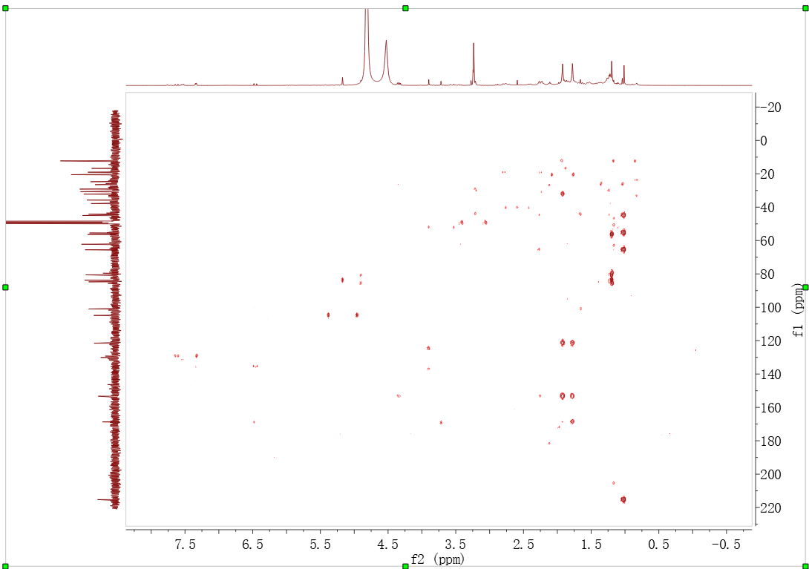
Supplementary Fig. 13. HMBC spectrum of peruranolide B (2) in MeOD
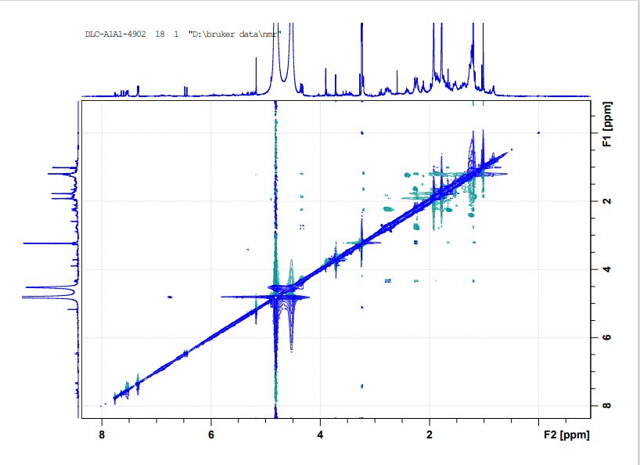
Supplementary Fig. 14. ROESY spectrum of peruranolide B (2) in MeOD
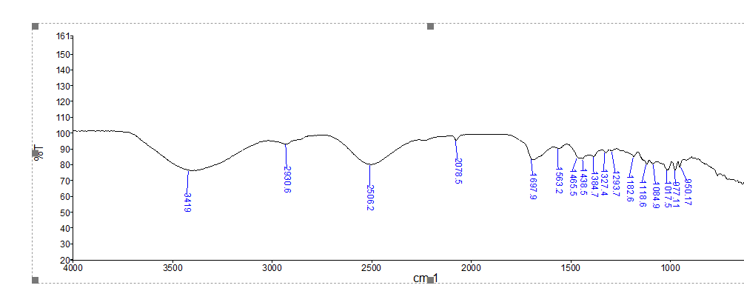
Supplementary Fig. 15. IR spectrum of peruranolide B (2)

Event#: 2 MS(E-) Ret. Time : 14.040 Scan# : 2108
Rank | Score | Formula (M) | Ion | Meas. m/z | Pred. m/z | Diff (mDa) | Diff (ppm) | Iso Score | DBE
1 | 0.00 | C₂₈ H₃₈ O₈ | [M-H]⁻ | 501.2493 | 501.2494 | -0.1 | -0.20 | 0.00 | 10.0

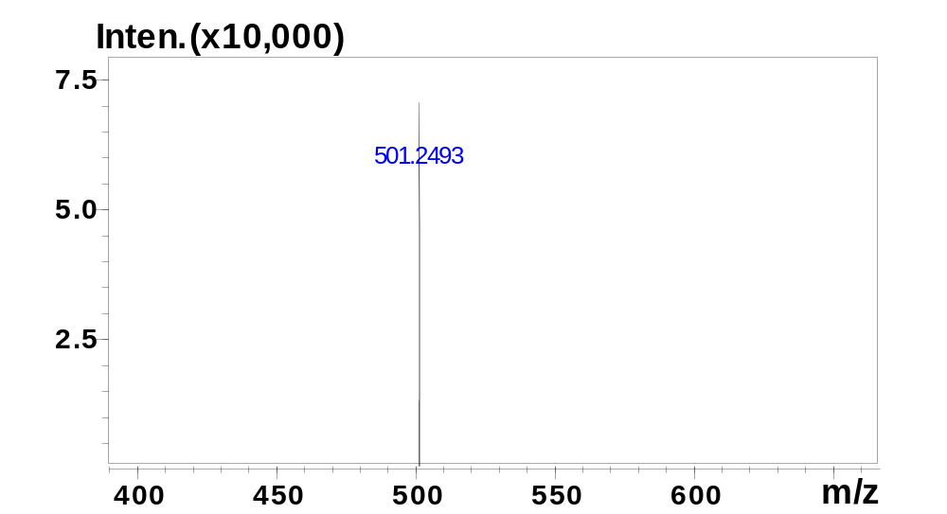
Supplementary Fig. 16. HRESI (-) MS spectrum of peruranolide B (2)

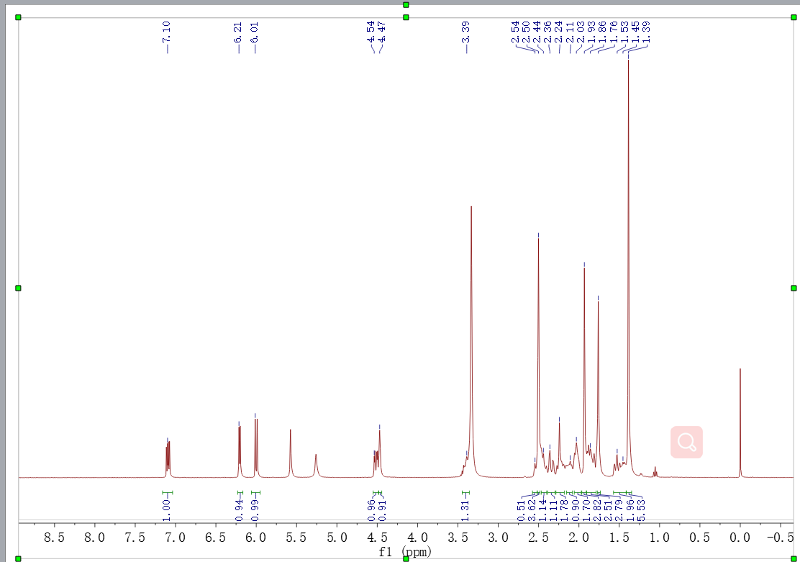
Supplementary Fig. 17. ¹H NMR spectrum of peruranolide C (3) in DMSO-d₆
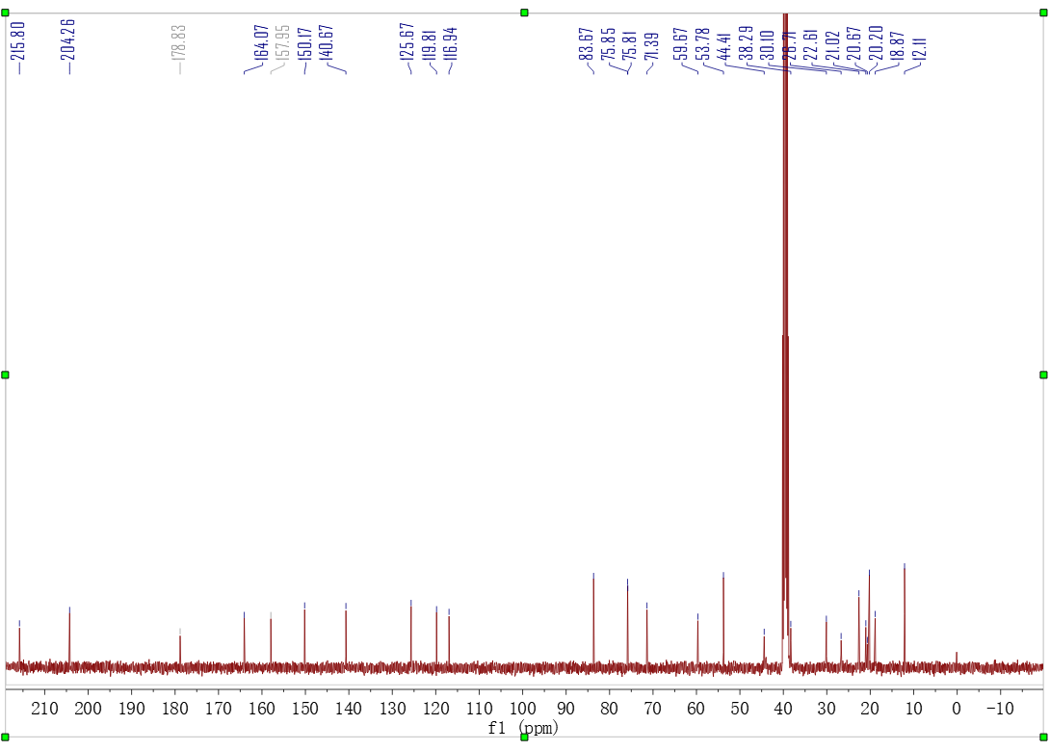
Supplementary Fig. 18. ¹³C NMR spectrum of peruranolide C (3) in DMSO-d₆
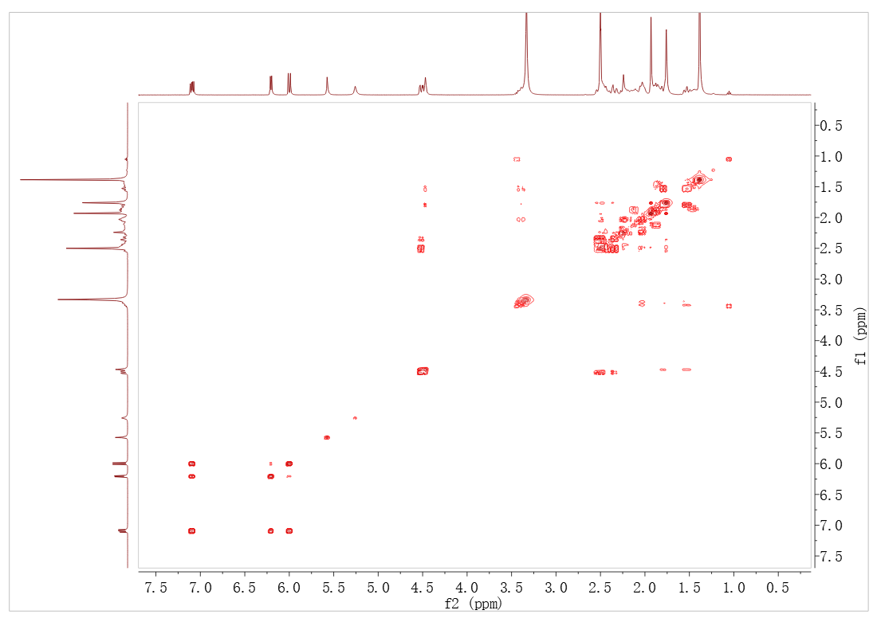
Supplementary Fig. 19. ¹H-¹H COSY spectrum of peruranolide C (3) in DMSO-d₆
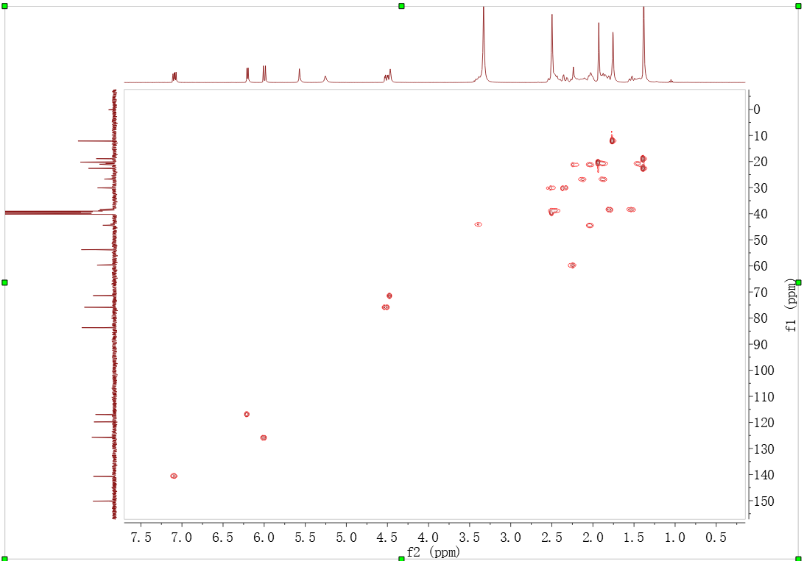
Supplementary Fig. 20. HSQC spectrum of peruranolide C (3) in DMSO-d₆
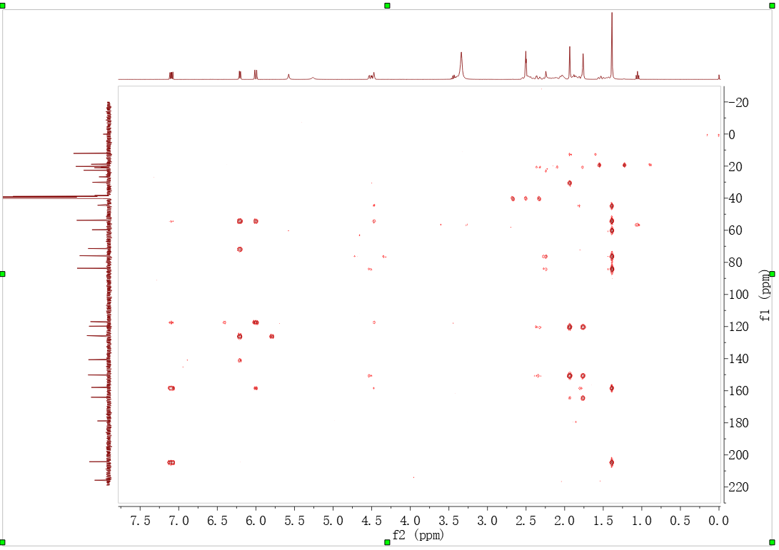
Supplementary Fig. 21. HMBC spectrum of peruranolide C (3) in DMSO-d₆
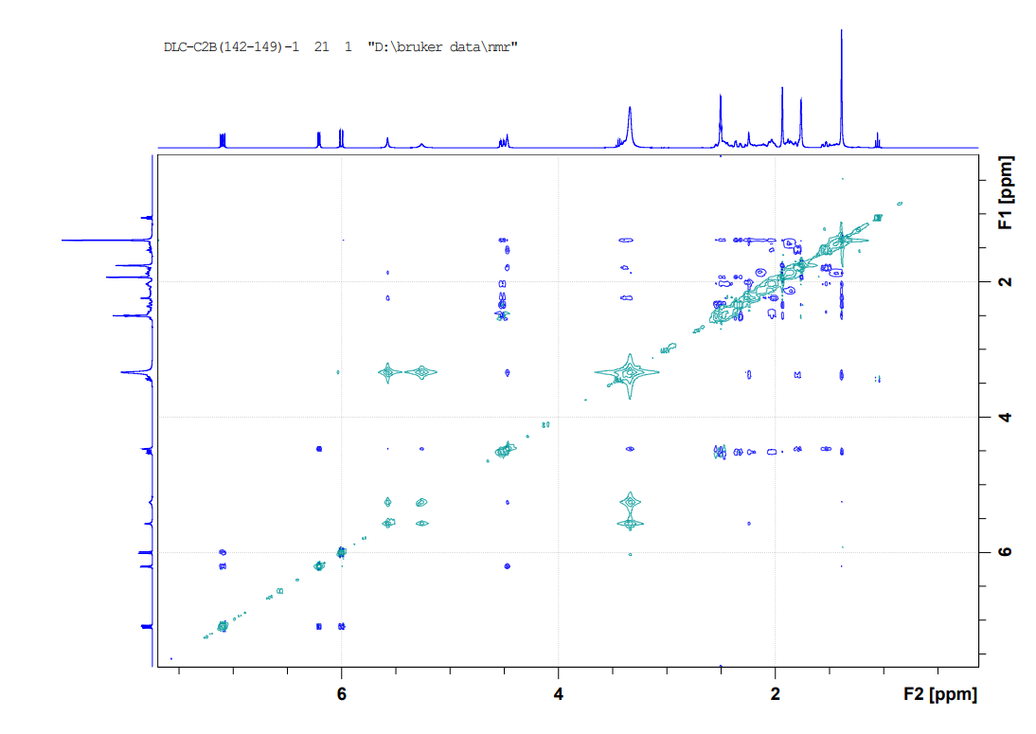
Supplementary Fig. 22. ROESY spectrum of peruranolide C (3) in DMSO-d₆
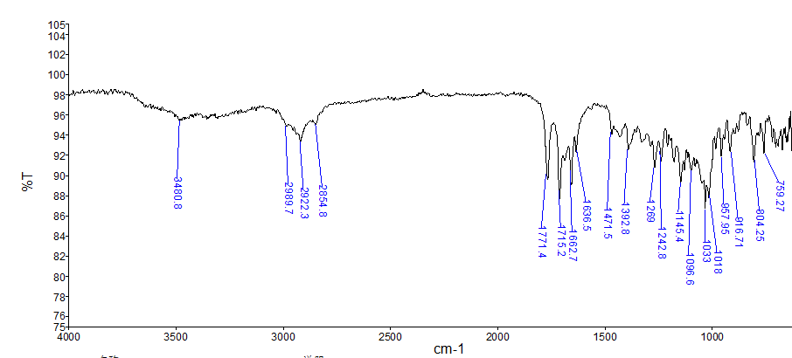
Supplementary Fig. 23. IR spectrum of peruranolide C (3)

Event#: 1 MS(E+) Ret. Time : 13.693 Scan# : 4109
Rank | Score | Formula (M) | Ion | Meas. m/z | Pred. m/z | Diff (mDa) | Diff (ppm) | Iso Score | DBE
1 | 58.88 | C₂₈ H₃₄ O₈ | [M+NH₄]⁺ | 516.2601 | 516.2592 | 0.9 | 1.74 | 59.99 | 12.0

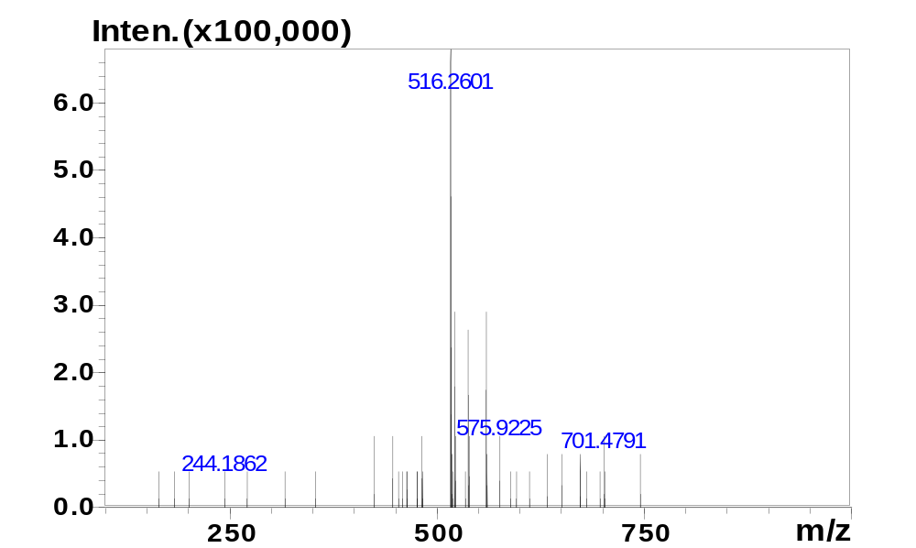
Supplementary Fig. 24. HRESI (+) MS spectrum of peruranolide C (3)

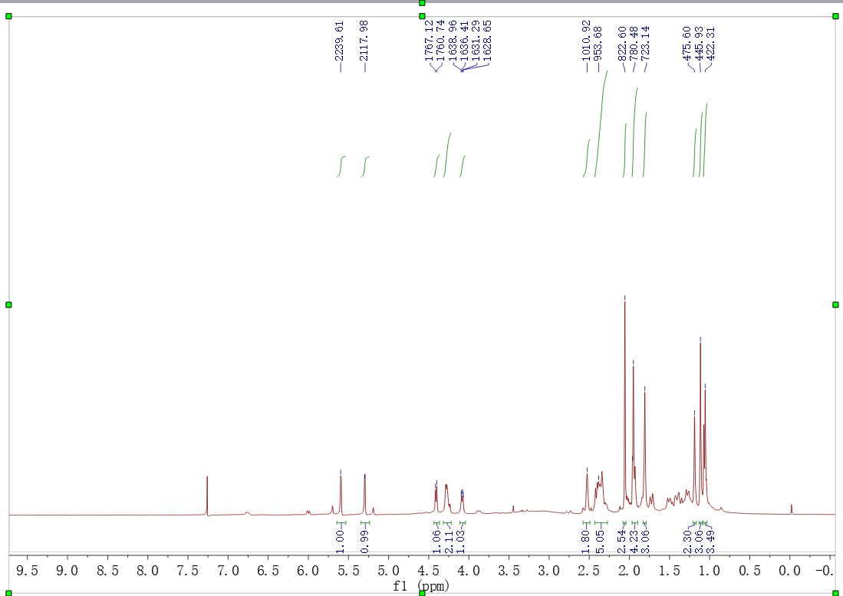
Supplementary Fig. 25. ¹H NMR spectrum of peruranolide D (4) in CDCl₃
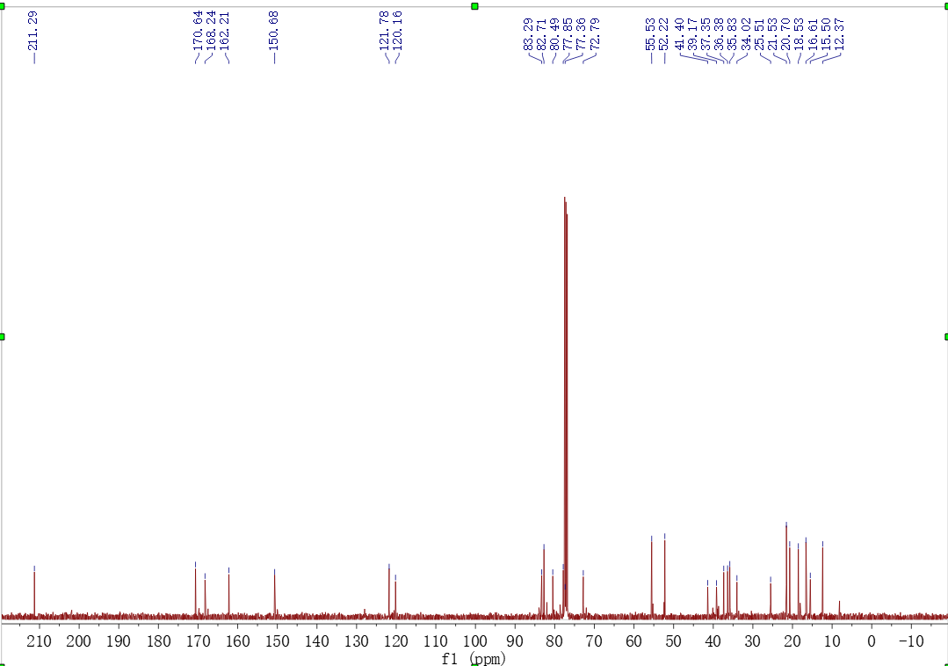
Supplementary Fig. 26. ¹³C NMR spectrum of peruranolide D (4) in CDCl₃
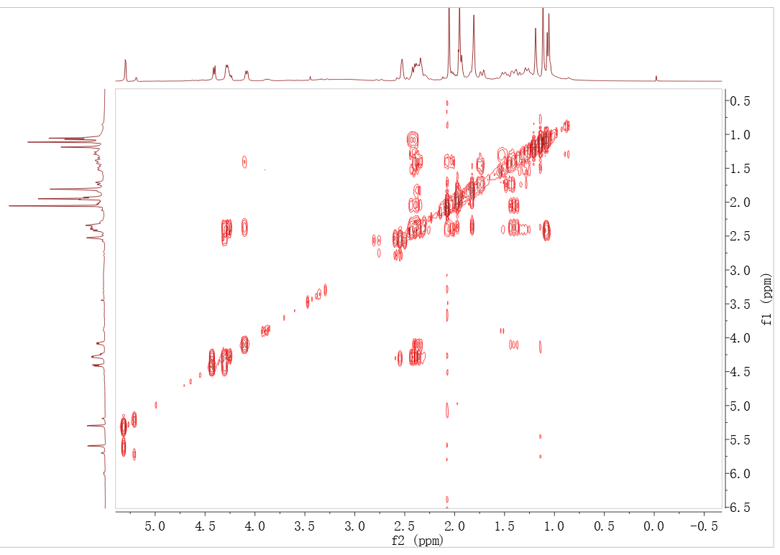
Supplementary Fig. 27. ¹H-¹H COSY spectrum of peruranolide D (4) in CDCl₃
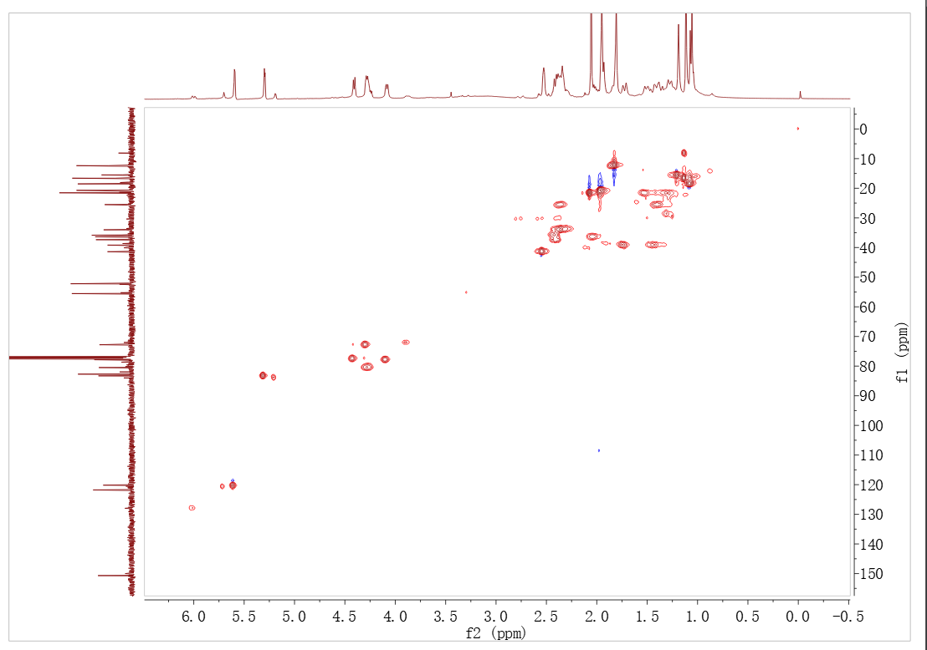
Supplementary Fig. 28. HSQC spectrum of peruranolide D (4) in CDCl₃
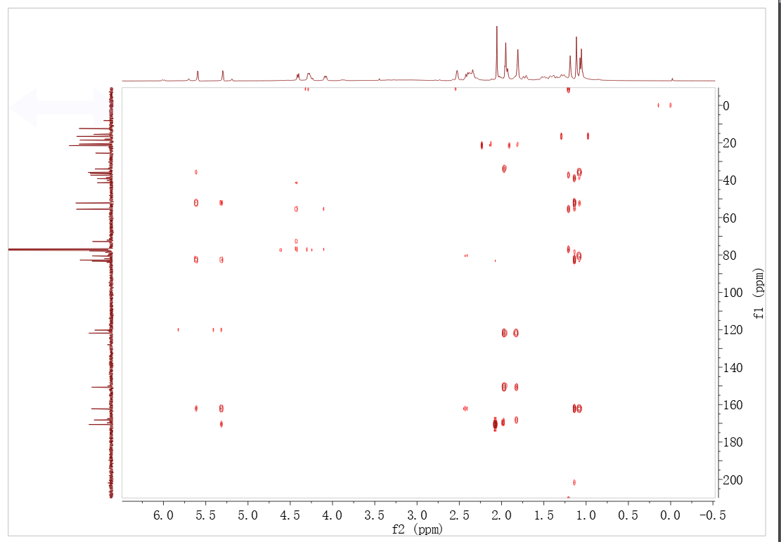
Supplementary Fig. 29. HMBC spectrum of peruranolide D (4) in CDCl₃
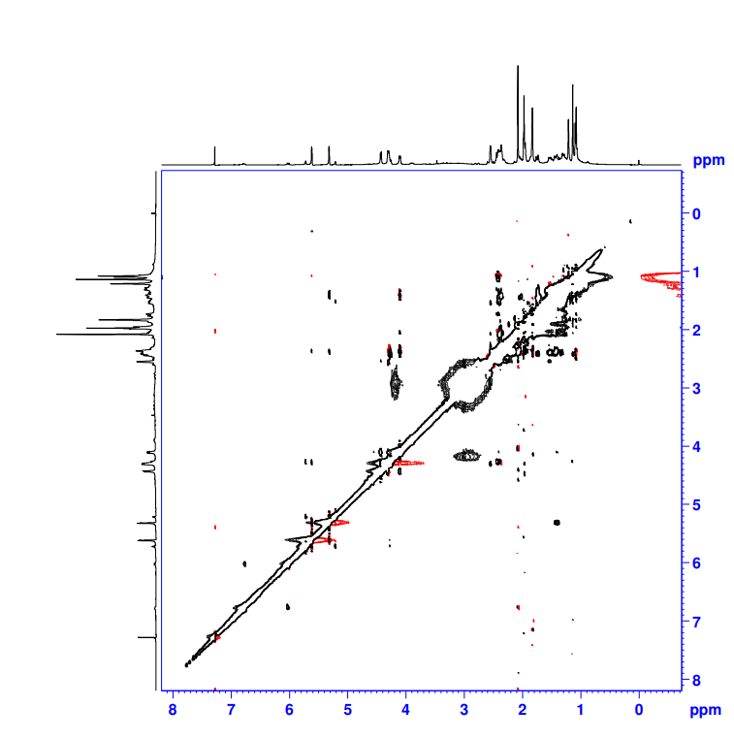
Supplementary Fig. 30. NOESY spectrum of peruranolide D (4) in CDCl₃
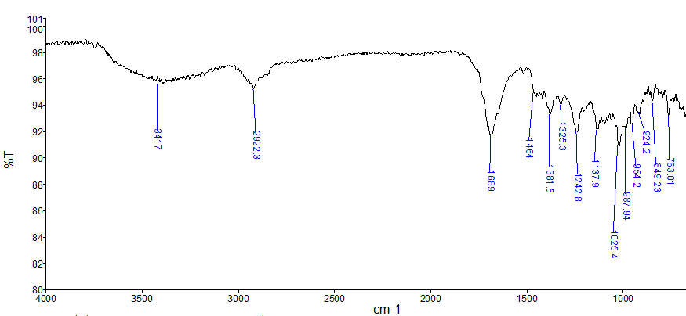
Supplementary Fig. 31. IR spectrum of peruranolide D (4)

Event#: 1 MS(E+) Ret. Time : 7.707 Scan# : 2313
Rank | Score | Formula (M) | Ion | Meas. m/z | Pred. m/z | Diff (mDa) | Diff (ppm) | Iso Score | DBE
1 | 58.17 | C₃₀H₄₀O₉ | [M+NH₄]⁺ | 562.3003 | 562.3011 | -0.8 | -1.42 | 58.78 | 11.0

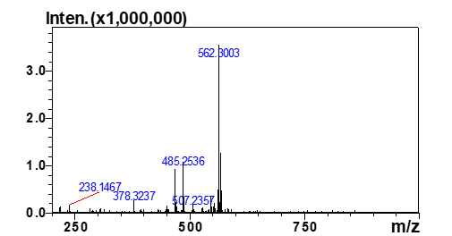
Supplementary Fig. 32. HRESI (+) MS spectrum of peruranolide D (4)

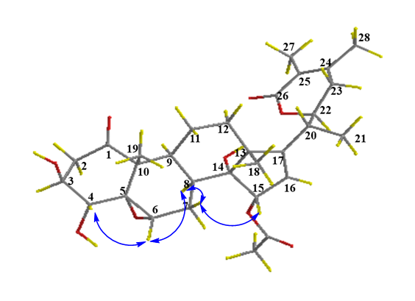
Supplementary Fig. 33. Key NOESY correlation for peruranolide D (4)

Supplementary Table 2-1. ¹³C NMR data of Compounds 4 and Physaminimin F (101 MHz)
position | 4¹ | 4² | Physaminimin F ²
1 | 211.3 | 213.5 | 213.1
2 | 41.4 | 42.3 | 43.7
3 | 72.8 | 74.8 | 69.4
4 | 77.5 | 78.2 | 78.6
5 | 77.4 | 77.6 | 65.0
6 | 77.9 | 79.3 | 60.8
7 | 25.5 | 27.0 | 25.9
8 | 36.4 | 37.7 | 36.5
9 | 37.4 | 39.0 | 39.5
10 | 55.5 | 56.7 | 51.9
11 | 21.5 | 21.6 | 21.9
12 | 39.2 | 39.9 | 38.5
13 | 52.2 | 53.7 | 53.6
14 | 82.7 | 83.3 | 83.0
15 | 83.3 | 84.3 | 84.9
16 | 121.8 | 122.3 | 122.6
17 | 162.2 | 162.7 | 163.1
18 | 16.6 | 16.7 | 16.4
19 | 15.5 | 16.0 | 15.0
20 | 35.8 | 36.3 | 36.6
21 | 18.5 | 18.0 | 18.2
22 | 80.5 | 80.4 | 80.7
23 | 34.0 | 33.3 | 33.6
24 | 150.7 | 152.8 | 152.9
25 | 121.8 | 122.0 | 122.2
26 | 168.3 | 169.1 | 169.2
27 | 12.7 | 12.4 | 12.5
28 | 20.7 | 20.4 | 20.5
15-OAc | 21.5 | 21.6 | 21.6
15-OAc | 170.6 | 172.1 | 171.9
¹ CDCl₃ was used as solvent.
² CD₃OD was used as solvent.

